A Project Report on
BATTERY MONITIORING SYSTEM USING IOT
to be submitted in partial fulfilment of the requirements
for the award of degree of

BACHELOR OF ENGINEERING
(Mechanical Engineering)

Submitted by:
BMHB03 | : | YASH GAJANAN MARKAD
BMHB04 | : | TIRTHRAJ HEMRAJ AVASTI
BMHB04 | : | TEJAS DILIP KINGE
BMHB39 | : | DHEERAJ PRAMOD KHODKE
Group No. 52

Prof. Jitendra S. Narkhede
Guide
Professor
Mechanical Engineering Department


MECHANICAL ENGINEERING DEPARTMENT
DR. D. Y. PATIL INSTITUTE OF TECHNOLOGY, PIMPRI
(Affiliated to Savitribai Phule Pune University, Pune)
PUNE – 411 018, MAHARASHTRA
2023-2024
Certificate
This is to certify that the following group of bonafide students from the Mechanical Engineering Department have successfully completed the prerequisites as laid down by the Savitribai Phule Pune University, Pune in the form of a report as per the course structure for the Project Stage – II.
Exam Seat No. | Roll No. |  | Name of the project group students
 | BMHB03 | : | YASH GAJANAN MARKAD
 | BMHB04 | : | TIRTHRAJ HEMRAJ AVASTI
 | BMHB04 | : | TEJAS DILIP KINGE
 | BMHB39 | : | DHEERAJ PRAMOD KHODKE

It is herewith certified that this project work has not been submitted for award of any degree/diploma to any other university in India or abroad.

Prof. Jitendra S. Narkhede | Dr. Nitin P. Sherje
Guide | Professor and Head,
Professor  Mechanical Engineering Department | Mechanical Engineering Department  DIT, Pimpri
Dr. L. K. Wadhwa
Principal,
DIT, Pimpri

Date: Saturday, 25 May 2024
Place: DIT, Pimpri
Declaration
With this, I certify that the report entitled “BATTERY MONITORING SYSTEM USING IOT” was submitted in partial fulfilment of the requirements for the award of the degree of Bachelor of Engineering in Mechanical Engineering to Savitribai Phule Pune University, Pune is an authentic record of project work carried out by us under the supervision and guidance of Prof. Jitendra S. Narkhede.
The work incorporated in this report has not been submitted elsewhere for the award of any degree/diploma in India or abroad.
Exam Seat No. | Roll No. |  | Name of the project group students | Signature
 | BMHB03 | : | YASH GAJANAN MARKAD
 | BMHB04 | : | TIRTHRAJ HEMRAJ AVASTI
 | BMHB16 | : | TEJAS DILIP KINGE
 | BMHB39 | : | DHEERAJ PRAMOD KHODKE
Undergraduate students,
Mechanical Engineering Department,
DIT, Pimpri, Pune – 411018 (Maharashtra), INDIA

Place: DIT, Pimpri
Date: Wednesday, 22 May 2024

Acknowledgements
I would like to express my sincere gratitude to all those who are currently working on this project on "Battery Management System using IoT." This endeavour would not have been possible without the support and assistance of various individuals and organizations.
First and foremost, I would like to thank my advisor Prof. Jitendra S. Narkhede sir for their invaluable guidance and mentorship throughout the project. Their expertise and continuous support were instrumental in shaping the project's direction and ensuring its success.
I extend my heartfelt thanks to the members of my research team for their dedication, hard work, and collaborative efforts in developing the IoT-based Battery Management System. Your commitment and expertise were crucial in achieving the project's objectives.
I would like to acknowledge the encouragement and support from my friends and family, who stood by me during the project's difficulties. Your unwavering belief in me was a source of motivation.
Finally, I am thankful to all the research papers, online resources, and open-source contributors whose work laid the foundation for our project.

Abstract

Battery Management Systems (BMS) are used in many industrial and commercial systems to make the battery operation more efficient and for the estimation to keep the battery state, as long as possible, away from destructive state, to increase battery lifetime. For this purpose, many monitoring techniques are used to monitor the battery state of charge, temperature and current. In the current paper, the monitoring system for battery powered Electric Vehicles (EV) has been implemented and tested. This system evaluates and displays the battery temperature, charging/discharging current and State of Charge (SOC) for the considered model battery. For monitoring purposes, digital and analog sensors with microcontrollers are used. The battery information and the obtained results explaining the main characteristics of the system are presented by photographs and some experimental results are given by the LCD screen.
Electric vehicles are the way of the future. The rising EV market, along with the diminishing supply of petroleum fuels, demands the development of more efficient EVs. A battery management system (BMS) is an essential component of any electric vehicle. It consists of several electrical and electronic circuits (including converter and inverter circuits) that have been programmed to monitor and extract the maximum output from a battery system. The chemical reactions are what determine the battery’s performance. The performance of a battery degrades as chemicals decay. As a result, these features of a battery must be regularly monitored. Because of their high charge density and lightweight, Lithium-ion batteries have proven to be a popular choice among electric vehicle producers. Even though these batteries have a lot of power for their size, they are quite unstable. It is critical that these batteries are never overcharged or discharged, requiring the use of voltage and current regulators. In this research paper, we will monitor various aspects of the vehicles like current, Voltage, SOC, and temperature with the help of NodeMCU which is the Wi-fi enabled microchip that will send the data or crucial parameters to the server which is the Thing Speak. Therefore, in this way we can monitor these parameters from anywhere and monitor battery health.

CONTENTS
Chapter No. |  | Description | Page No.
 |  | Acknowledgements
 |  | Abstract
 |  | List of tables
List of figures
Nomenclature
 |  | Introduction
 |  | 1.1 Electric vehicle
 |  | - History of Electric Vehicle
  - Battery Management System
    - Battery Monitoring System Design Considerations
  - Battery Swapping Station
    - Advantages of Battery Swapping Station
    - Concerns
1.4 Literature review
1.5 Project objectives
1.6 Proposed method
2.1 Methodology
2.2 Specification and Details
2.3 Code
3.1 Result and discussions
4.1 Conclusions and Future Scope
5.1 References

LIST OF FIGURES
Figure No. | Description | Page No.
1 | Block Diagram for BSS …………………………………………...
2  3  4  5  6  7 | Block Diagram for BMS…………………………………………...  Arduino Circuit Diagram………………………………………….  ATmega328P ………………………………………………………  Pin Diagram of LCD ………………………………………………  Circuit Diagram-Power Supply…………………………………….  Battery Pack……………………………………………………….

LIST OF TABLES
Table No. | Description | Page No.
1 | LCD Pin description …………………………………………...
2 | BAUD RATE FORMULA…………………………………….

NOMENCLATURE
- Battery Monitoring System (BMS): This is the overarching system that combines IoT technology and sensors to monitor the status and performance of batteries. The BMS collects, transmits, and analyses data to ensure the optimal operation of batteries.
- Internet of Things (IoT): IoT refers to the network of physical devices, sensors, and other objects that are connected to the internet, allowing them to collect and exchange data. In the context of a BMS, IoT technology enables remote monitoring and data transmission.
- Battery Sensors: These are the devices placed on or near batteries to collect data on various parameters. Common types of battery sensors include temperature sensors, voltage sensors, current sensors, and state of charge sensors.
- Connectivity: In a BMS using IoT, connectivity options include Wi-Fi, cellular networks, or LPWAN (Low Power Wide Area Network). These methods are used to transmit battery data to a central platform for analysis.
- Cloud-Based Platform: This platform, hosted on the internet, serves as the central repository for battery data. It processes and stores the data, enabling real-time analysis and access from remote locations.
- Telemetry: Telemetry is the process of collecting and transmitting data remotely. In the context of a BMS, telemetry technology is used to gather battery performance data and transmit it to the central platform.
- Data Analytics: This involves using algorithms and machine learning techniques to analyse the collected battery data. Data analytics can identify patterns, anomalies, and trends, providing insights into battery performance and health.
- Real-Time Monitoring: The BMS offers real-time monitoring, which means that battery data is continuously updated and displayed without significant delay, allowing for immediate action in response to critical information.
- Predictive Maintenance: Predictive maintenance involves using historical data and analytics to predict when maintenance or servicing of batteries will be required, reducing downtime, and preventing unexpected failures.
- Anomaly Detection: Anomaly detection algorithms are used to identify deviations from expected battery behaviour. When an anomaly is detected, the system can trigger alerts for maintenance or investigation.
- User Interface: The user interface is a dashboard or application that allows users to access and interact with the battery data. It typically provides visualizations, historical data, and alerts for easy monitoring.
- Battery Management: Battery management encompasses the strategies and actions taken to ensure the optimal performance and longevity of batteries. IoT-based BMS is a critical component of battery management systems.
- Energy Efficiency: Monitoring and optimizing battery performance contributes to energy efficiency by ensuring that batteries are used effectively, reducing waste, and conserving energy resources.

Chapter 1
Introduction

1.1 ELECTRIC VEHICLE
Electric vehicle (EV) is one that is made to run by an electric motor rather than an internal-combustion engine (IC). It generates energy by burning a mixture of Petroleum and its other products. Due to Which, these vehicles are found out to be a one of the replacements for current generation of vehicles in order to address challenges such as rising pollution, global warming, and natural resource depletion. Electrical vehicles are attracting customers due to its environment-friendly nature as it does not have an internal-combustion engine which creates harmful gases for the planet, also they have less cost of maintenance, and they are potential to a tax credit as the customer is cutting down the impact on the environment by choosing a zero-emission system. Countries like the United States, China and Japan had updated its policies and standards to support the development of EVs.

1.1.1 History of Electric Vehicles
Electric vehicles, which run on batteries rather than gas engines, are becoming more common. Electric vehicles are preferred by those who want to safeguard the environment and maybe go greener. However, many people are astonished to hear that electric vehicles are not a new technology. While it is unclear who invented the first electric car, electric motors were clearly in use as early as the 1800s. Around 1828, Anyos Jedlik invented the very first electric motor [1]. Using a small electric engine, he developed a self-moving tiny model automobile. A bigger electric motor designed by Scottish inventor Robert Anderson has been used to run a carriage between 1832 and 1839 [2].
American innovators returned to the electric car in the 20th century. William Morrison created what many consider to be the first practical electric car around this.
power source to charge the traction battery pack.

      - DC/DC converter: This device converts the high voltage DC power from the traction battery pack into the low voltage DC power needed to run vehicle accessories and charge the auxiliary battery.
      - DC/DC converter: This motor uses energy from the traction battery pack to move the wheels of the vehicle. Engine generators are used to power and rejuvenate various vehicles.
      - On-board charger: Charges the traction battery by converting the input AC voltage from the charging port to DC. Connected to the charger, it analyses battery parameters such as voltage, current, temperature and charge status during the charging process.
      - Power electronics controller: This unit controls the speed of the electric traction motor and the torque produced by controlling the flow of electrical energy supplied by the traction battery.
      - Thermal system (cooling): This system maintains a safe operating temperature range for motors, electric motors, power electronics, and other components.
      - Traction battery pack: The electric traction motor consumes the power stored here.
      - Transmission (electric): The transmission is responsible for transferring mechanical energy from the traction motor to the wheels.

1.2 BATTERY MANAGEMENT SYSTEM

A battery pack is an arrangement of battery cells electronically arranged in a row x column matrix format to be able to produce a specified range of current and voltage for a given amount of time in response to projected load conditions. The following are common BMS responsibilities:

- Battery Monitoring
- Battery protection
- Estimating the operational state of the battery
- Constantly improving battery performance
- Reporting operational status to other devices
In this situation, the term "battery" refers to the entire pack; nevertheless, in the overall battery pack assembly, individual cells or clusters of cells known as modules are subjected to monitoring and control activities. Rechargeable lithium-ion cells have the highest energy density and are used in computer and electric car battery packs. They operate well, but if used outside of a relatively small safe operating area, they can be harsh, resulting in everything from battery degeneration to outright danger. The BMS does have a difficult job profile, and the complete complexity and oversight it requires may include digital, control, electrical, hydraulic, and thermal domains.

1.2.1 Battery Monitoring System Design Considerations
When constructing a BMS, a number of aspects must be taken into account. The entire set of concerns is dependent on the BMS’s intended end application. Apart from electric vehicles, BMSs are utilized wherever a lithium battery pack is present, such as in solar panels, windmills, and power walls. A BMS design should take into account all or many of the following characteristics, regardless of the application [5].

      - Controlling Discharge: A BMS main goal is to keep lithium cells within their safe operating range. A normal Lithium 18650 cell, for example, will have an undervoltage rating of roughly 3V. The BMS is responsible for ensuring that none of the cells in the pack are discharged below 3V.
      - Charging Control: The BMS should also monitor the charging process in addition to the discharging. When batteries are charged incorrectly, they are more likely to be damaged or have a shorter lifespan. A two-stage charger is used to charge lithium batteries. The charger outputs a consistent current to charge the battery in the first stage, which is known as Constant Current (CC). When the battery is nearly full, the second stage, known as the Constant Voltage (CV) stage, is activated, in which the battery is fed with a constant voltage at a very low current. To avoid overcharging or fast charging the batteries, the BMS should ensure that both the voltage and current during charging do not exceed set limitations. The datasheet for the battery will tell you what the maximum charging voltage and current are.
      - Determination of State-of-Charge (SOC): SOC can be thought of as the electric vehicle’s fuel gauge. It truly informs us the percentage of the pack’s battery capacity. Exactly like the one in our phone. However, it is not as simple as it appears. To anticipate the capacity of the battery, the voltage and charge/discharge current of the pack should continually be monitored. There are a variety of algorithms that may be used to compute the SOC of the Battery pack once the voltage and current have been measured. The coulomb counting approach is the most often used method; we will go over this in more detail later in the essay. A BMS is also in charge of measuring the readings and determining the SOC.
      - State-of-Health (SOH) Determination: The capacity of a battery is determined by its age and operating temperature, as well as its voltage and current profile. Based on the battery’s usage history, the SOH measurement informs us about the battery’s age and predicted life cycle. This allows us to determine how much the EV’s mileage (distance travelled after a full charge) decreases as the battery ages, as well as when the battery pack needs to be changed. The SOH should be calculated and tracked by the BMS as well.
      - Cell Balancing: A BMS’s other important job is to keep cells balanced. In a pack of four cells connected in series, for example, the voltage of all four cells should always be the same. If one cell has a lower or higher voltage than the others, the entire pack will suffer. For example, if one cell has 3.5V while the other three have 4V, the entire pack will suffer. These three cells will reach 4.2V during charging while the other has only reached 3.7V, and this cell will be the first to discharge to 3V before the other three. As a result of this solitary cell, all of the other cells in the pack are unable to reach their full potential, compromising efficiency. To address this issue, the BMS must perform a process known as cell balancing. There are many different types of cells balancing strategies, but the active and passive cell balancing approaches are the most popular. The notion behind passive balancing is that cells with excess voltage are forced to discharge through a load, such as a resistor, in order to attain the voltage value of the other cells. The stronger cells will be employed to charge the weaker cells to equalize their potentials while active balancing is in progress. In a later piece, we’ll go over cell balance in further detail.
      - Controlling the temperature: The operating temperature of a Lithium battery pack has a considerable impact on its life and efficiency. In warmer climates, the battery discharges faster than in normal room temperatures. Adding to this, the use of high current would raise the temperature even more. In a battery pack, this necessitates the use of a thermal system (usually oil). This thermal system should not only be able to lower temperatures, but also be able to raise them in cold climes if necessary. The BMS is in charge of monitoring individual cell temperatures and controlling the thermal system to keep the battery pack at a consistent temperature.

      - Powered from the Battery itself: The battery is the only source of power in the electric vehicle. As a result, a BMS should be built to run on the same battery that it is supposed to preserve and maintain. This may appear easy, but it adds to the complexity of the BMS design.
Less Ideal Power: Even if the car is operating, charging, or in optimal mode, the BMS should be active and functioning. As a result, the BMS circuit must be operated continually, and the BMS must consume very little power in order to avoid overcharging the battery. When an electric vehicle (EV) is left uncharged for weeks or months, the BMS and associated electronics tend to drain the battery on their own, requiring it to be cranked or charged before usage. Even popular automobiles like Tesla are not immune to this challenge.
      - Galvanic Isolation: The BMS serves as a link between the EV’s battery pack and its ECU. The ECU must receive all of the data collected by the BMS in order for it to be presented on the instrument cluster or dashboard. As a result, the BMS and the ECU should be in constant communication, preferably using a standard protocol such as CAN communication or the LIN bus. Between the battery pack and the ECU, the BMS should be able to provide galvanic isolation.
      - Data Logging: Because the BMS must store a huge amount of data, it requires a large memory bank. Only if the battery’s charging history is known can values like the Sate-of-health SOH be determined. As a result, the BMS must keep track of the battery pack’s charge cycles and charge time from the time it was installed, and interrupt this data as needed. This also assists engineers in offering after-sales service or identifying a problem with the EV.
      - Accuracy: The voltage across a cell steadily increases or lowers as it is charged or discharged. Unfortunately, a lithium battery’s discharge curve (Voltage vs time) has flat portions, resulting in very little voltage change. To determine the value of SOC or use it for cell balance, this change must be correctly measured. The precision of a well-designed BMS could be as high as 0.2mV, but it should be at least 1mV-2mV. A 16-bit ADC is typically employed in the procedure.
      - Processing Speed: To determine the value of SOC, SOH, and other parameters, an EV’s BMS must conduct a lot of numerical crunching. There are a variety of techniques for this, and some even employ machine learning to do the work. As a result, the BMS is a processor-intensive device. Aside from that, it must measure cell voltage across hundreds of cells and detect minor changes.

1.3 BATTERY SWAPPING STATION

Electric vehicles majorly face the problem of range anxiety and long charging period time which can be overcome by implementing a Battery Swapping Station. In this concept, when the vehicle is scheduled to come to a station, then the discharged battery pack is replaced by the charged one. The battery can be replaced in one of two ways:
1. Automated Robots- This is a method of replacing the battery pack that does not require the use of human workers.
2. Manually- In this procedure, a battery which is not charged i.e. a discharged battery is removed and a new charged battery is placed with the help of man available at the station. This process will take longer than the previous one, and because manpower is involved, the cost will go up.

1.3.1 Advantages of Battery Swapping Station

The owners of the EV, the Station, and the Power System are all linked, and this process benefits them all.
1. Because the Electric Vehicle is owned by the Station, it decreases the cost of the Electric Vehicle, which is the most expensive part of the EV.
2. While refuelling the gasoline car, the discharged battery can be replaced and swapped with a charged battery.
3. The owner is not obligated to install the power charger for the battery on his or her premises.
4. The owner’s concerns about charging time when traveling large distances were solved.

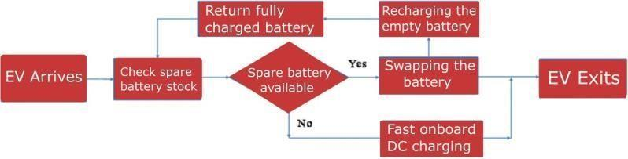

Figure 1.1: Block Diagram for BSS

1.3.2 Concerns

In an electric vehicle, when we swap the battery at the swapping stations there is no way to monitor the health card of the battery and how much battery is drained and what is the condition of the battery. In this way, pricing of the battery will also be compromised as someone could pay more price for less efficient battery than the more efficient battery. To avoid this, a proper system and information centre has to be developed. To maintain complete transparency within the operations, all data linked to batteries must be secured on cloud storage and made accessible to both authorities and customers. Following the swap, the battery of the vehicle are going to be immediately monitored for its state of charge, state of health (SOH), remaining charge, battery age, battery life, and number of charging and discharging cycles completed, and therefore the owner are going to be informed of the costs incurred likewise because the estimated time it will regard him to receive his fully charged battery. Therefore, customer adoption of electric vehicles will play a significant part in reducing the number of harmful gasses in the environment. In order to attract clients to it, swapping technology is in high demand in many parts of the world right now. BSS methods are emerging as a possible alternative to the standard battery charging station approach since, they give dedicated stakeholders with a broader set of revenue options.
The integration of Battery Monitoring Systems (BMS) is crucial for enhancing the performance, safety, and longevity of batteries across various applications, including electric vehicles, renewable energy storage, and portable electronics. However, the effective implementation of BMS is often accompanied by challenges and concerns that need to be addressed to ensure optimal functionality and reliability.
This paper provides a comprehensive review and analysis of the concerns associated with Battery Monitoring Systems, along with the corresponding solutions and mitigation strategies. It begins by elucidating the importance of BMS in mitigating risks such as overcharging, over-discharging, thermal runaway, and capacity degradation, which can compromise battery performance and safety.
The paper then identifies common concerns related to BMS implementation, including accuracy and reliability of sensor measurements, complexity of data processing algorithms, communication latency, scalability, and compatibility with diverse battery chemistries and configurations. Each concern is examined in detail, discussing the underlying causes and potential consequences on battery operation and system performance.
Furthermore, the paper evaluates existing approaches and technologies aimed at addressing these concerns, such as sensor calibration techniques, fault-tolerant design principles, adaptive algorithms for data processing, real-time monitoring and diagnostics, and standardization efforts for interoperability and compatibility.
Moreover, the paper highlights the importance of user education and training in ensuring the effective utilization of BMS capabilities and functionalities, as well as the need for continuous monitoring and maintenance to detect and mitigate potential issues in real-time.
Finally, the paper concludes with insights into future research directions and emerging technologies that hold promise for overcoming current challenges and further advancing the field of Battery Monitoring Systems.
Keywords: Battery Monitoring System, BMS, concerns, challenges, safety, reliability, sensor calibration, fault-tolerant design, interoperability, standardization.

1.4 Literature review

1. Title: “Battery Health Monitoring for Commercialized Electric Vehicle Batteries: Lithium-Ion”
Author: Fawad Ali Shah, Shehzad Shahzad Sheikh, Umar Iftikhar
Title: Enhancing Battery Health Monitoring for Commercialized Lithium-Ion Electric Vehicle Batteries
Abstract:
This paper authored by Fawad Ali Shah, Shehzad Shahzad Sheikh, and Umar Iftikhar focuses on advancing battery health monitoring strategies tailored specifically for commercialized lithium-ion electric vehicle (EV) batteries. With the rapid growth of the EV market, ensuring the longevity and reliability of lithium-ion batteries has become paramount. This paper provides a comprehensive analysis of battery health monitoring techniques, challenges, and future directions in the context of commercial EV batteries.
The paper begins by elucidating the importance of battery health monitoring in optimizing EV performance, extending battery life, and ensuring operational safety. It reviews the fundamental principles underlying lithium-ion battery operation and degradation mechanisms, emphasizing the critical parameters that influence battery health, such as state of charge, state of health, temperature, and cycling behaviour.
Drawing upon recent research and industry advancements, the paper explores state-of-the-art battery health monitoring methodologies, including electrochemical impedance spectroscopy, voltage and temperature profiling, and machine learning-based predictive analytics. It assesses the strengths and limitations of each approach and highlights emerging trends in real-time monitoring and diagnostic techniques.
Furthermore, the paper addresses the unique challenges associated with commercialized EV batteries, including heterogeneous usage patterns, varying environmental conditions, and degradation acceleration factors. It proposes tailored strategies for addressing these challenges, such as fleet-wide data analytics, adaptive modelling techniques, and collaborative ecosystem approaches.
Through case studies and practical examples, the paper demonstrates the efficacy of advanced battery health monitoring systems in identifying degradation patterns, predicting failure modes, and optimizing battery management strategies for commercial EV fleets. It underscores the importance of proactive maintenance and predictive analytics in minimizing downtime, reducing operational costs, and enhancing overall fleet efficiency.
In conclusion, the paper outlines future research directions and industry initiatives aimed at advancing battery health monitoring capabilities for commercialized lithium-ion EV batteries. It advocates for interdisciplinary collaboration, standardization efforts, and knowledge sharing to accelerate innovation and drive the widespread adoption of robust battery health monitoring solutions in the electric transportation sector.
Keywords: Battery Health Monitoring, Lithium-Ion Batteries, Electric Vehicles, Degradation Mechanisms, Predictive Analytics, Commercial Fleets.

Description: Batteries are widely utilized to power electric vehicles, hybrid electric vehicles (HEVs), and many other high-power applications. The battery is critical to their efficiency, safety, and reliability. Reliability. Initially, numerous types of batteries are discussed in this paper. According to the research, utilization in EVs and HEVs are explored. The most recent battery management methods (BMS). Lithium- ion batteries due to their extended life, a preferred source of EVs and HEVs, high power density, and good charging and charging efficiency performance discharge However, there are still some concerns. Li-ion batteries are used in a variety of applications, including complicated electrochemistry, battery deterioration, and battery accuracy health assessment. Vehicle electrification is a global trend that includes Asia and Pakistan. Following that, the article considers the economic, environmental, and energy efficiency implications of increased use of electric vehicles.

2.Title: “Battery Swapping Technology”
Author: Shubham Jain, Azures Ahmad, Mohammad Saad Allam
Title: Battery Swapping Technology: Revolutionizing Electric Vehicle Charging Infrastructure

Abstract:
Battery Swapping Technology (BST) presents a paradigm shift in the realm of electric vehicle (EV) charging infrastructure, offering a compelling solution to the challenges of range anxiety, long charging durations, and limited charging station availability. This paper, authored by Shubham Jain, Azures Ahmad, and Mohammad Saad Allam, provides a comprehensive examination of BST, elucidating its transformative potential, technical underpinnings, operational considerations, and market implications.
The paper begins by elucidating the rationale behind BST adoption, emphasizing its capacity to redefine the EV ownership experience by enabling rapid battery replenishment akin to traditional refuelling processes. It explores the foundational principles of BST, including standardized battery modules, automated swapping mechanisms, and networked charging stations.
Drawing upon recent research and industry developments, the paper delves into the technological advancements driving the evolution of BST, encompassing innovations in battery design, swapping infrastructure, and data analytics for predictive maintenance. It underscores the role of BST in fostering sustainability by facilitating the integration of renewable energy sources and optimizing energy grid management.
Furthermore, the paper addresses the multifaceted challenges inherent in BST deployment, ranging from interoperability issues and infrastructure investment to regulatory frameworks and user acceptance. It proposes strategic frameworks for mitigating these challenges, encompassing stakeholder collaboration, regulatory harmonization, and business model innovation.
Through insightful case studies and practical examples, the paper showcases the diverse applications and benefits of BST across various sectors, including public transportation, last-mile delivery, and shared mobility services. It underscores the pivotal role of BST in accelerating the electrification of transportation and advancing global efforts towards decarbonization.

In conclusion, the paper offers a forward-looking perspective on the future trajectory of BST, envisioning its pivotal role in shaping the future of sustainable mobility and energy storage ecosystems. It advocates for continued research, industry collaboration, and policy support to realize the full potential of BST as a catalyst for transformative change in the transportation landscape.

Keywords: Battery Swapping Technology, BST, electric vehicles, charging infrastructure, sustainability, technological advancements, operational challenges, market implications.

Description: The transportation industry contributes significantly to carbon emissions and pollutes the environment globally. Electric vehicles (EVs) have a significant promise for reducing carbon emissions. A Battery Swapping Station (BSS) is a promising mechanism for providing power to EVs while reducing long charging times at a Battery Charging Station. Swapping Technology is an excellent option for completing a long-distance interstate journey. This study investigates the advantage of establishing the BSS from many perspectives, and as a result, a methodology for swapping out batteries in significantly less time is given, taking into account the position of the battery to be fixed. This new approach can be used as a source of inspiration for a future framework that provides EVs with sensible and dependable charging.

3.Title: “Scalable and Decentralized Battery Management System for Parallel Operation Multiple Battery Packs”
Author: Shreyas Maitreyan, Himani Jain, Priyanka Pallial
Title: Towards Scalable and Decentralized Battery Management Systems for Parallel Operation of Multiple Battery Packs

Abstract:
This paper, authored by Shreyas Maitreyan, Himani Jain, and Priyanka Pallial, explores the development and implementation of scalable and decentralized Battery Management Systems (BMS) tailored for the parallel operation of multiple battery packs. With the increasing demand for high-capacity energy storage systems in various applications such as electric vehicles, renewable energy integration, and grid stabilization, the need for robust BMS architectures capable of managing parallel battery configurations has become imperative.
The paper begins by outlining the motivation behind scalable and decentralized BMS solutions, emphasizing their ability to accommodate the complexities inherent in parallel battery operation, including variations in state of charge, temperature gradients, and aging characteristics. It discusses the challenges associated with traditional centralized BMS architectures and highlights the advantages of decentralized approaches in terms of scalability, fault tolerance, and system robustness.
Drawing upon recent research and technological developments, the paper proposes a novel framework for designing scalable and decentralized BMS architectures capable of supporting parallel battery packs. This framework leverages distributed intelligence, communication protocols, and modular design principles to enable seamless integration and operation of multiple battery packs in parallel.
Furthermore, the paper explores key components and functionalities of the proposed BMS architecture, including distributed sensor networks, local state estimation algorithms, and peer-to-peer communication protocols. It evaluates the performance of the system under various operating conditions and scalability scenarios, demonstrating its effectiveness in ensuring balanced charging, thermal management, and fault isolation across multiple battery packs.
Through simulation studies and practical demonstrations, the paper showcases the feasibility and scalability of the proposed BMS architecture in real-world applications. It highlights the potential benefits of decentralized BMS solutions in terms of improved system efficiency, reliability, and adaptability to diverse operating environments.
In conclusion, the paper outlines future research directions and industry initiatives aimed at further advancing scalable and decentralized BMS technologies for parallel battery operation. It advocates for collaborative efforts, standardization efforts, and knowledge sharing to accelerate the adoption of robust BMS solutions in the burgeoning energy storage market.
Keywords: Battery Management System, Scalability, Decentralization, Parallel Battery Operation, Distributed Intelligence, Modular Design.

Description: Multiple lithium-ion battery packs operating in parallel are required for large-scale energy storage applications. Renewable energy storage systems, battery packs for large-scale automobiles such as electric trucks, tanks, armoured vehicles, diesel-electric submarines, and so on are examples of such uses. The existing method for parallel operation of numerous battery packs is highly hardware intensive. It necessitates a distinct pack management system acting as a master, as well as battery management systems in each of the battery packs deployed as slaves. This has a huge impact on the scalability of such systems because the number of battery packs that can be connected in parallel is entirely reliant on the capacity of the master. A decentralized pack management system is presented as an alternative in this study. The Suggested technique eliminates the need for master-slave battery pack configurations and eliminates the need for centralized hardware to manage the battery packs. Instead, this system allows individual Battery packs to communicate with one another on their own, allowing for decentralized pack administration [9].

4. Title: Battery Management System in Electric Vehicle
Author: Ananthraj C R, Arnab Ghosh
Title: Battery Management System in Electric Vehicles: Current Trends and Future Directions
Abstract:
Authored by Ananthraj C R and Arnab Ghosh, this paper provides a comprehensive overview of Battery Management Systems (BMS) in electric vehicles (EVs), analysing current trends and outlining future directions for research and development in this critical domain. As EVs continue to gain prominence as a sustainable transportation solution, the role of BMS in ensuring the efficiency, safety, and longevity of battery packs becomes increasingly vital.
The paper begins by elucidating the fundamental importance of BMS in electric vehicles, emphasizing its multifaceted role in monitoring battery health, optimizing energy utilization, and safeguarding against thermal runaway and overcharging. It reviews key components and functionalities of BMS, including cell balancing algorithms, state estimation techniques, and thermal management strategies.
Drawing upon recent advancements in BMS technology, the paper examines current trends shaping the EV landscape, such as the integration of artificial intelligence and machine learning algorithms for predictive maintenance, the development of bidirectional charging capabilities for vehicle-to-grid applications, and the standardization of communication protocols for interoperability among different EV platforms.
Furthermore, the paper delves into emerging challenges and opportunities in BMS design and implementation, including the need for robust cybersecurity measures to protect against malicious attacks, the optimization of BMS algorithms for heterogeneous battery chemistries, and the integration of advanced sensing technologies for real-time performance monitoring.
Through case studies and practical examples, the paper showcases best practices and innovative solutions adopted by leading EV manufacturers to enhance BMS performance and reliability. It highlights the importance of interdisciplinary collaboration between researchers, engineers, and industry stakeholders in driving continuous innovation in BMS technology.
In conclusion, the paper outlines future research directions and strategic recommendations for advancing BMS in electric vehicles, including the development of standardized testing protocols, the exploration of novel materials for battery electrodes, and the exploration of modular and scalable BMS architectures to accommodate diverse EV platforms and use cases.
Keywords: Battery Management System, Electric Vehicles, BMS, Trends, Challenges, Future Directions.
Description: The most crucial component of any electric vehicle (EV) is battery storage, which stores the energy required for the vehicle’s operation. So, in order to get the most out of a battery while also ensuring its safety, it is vital to have an effective battery management system in place. It monitors the parameters, calculates SOC, and provides the services required to ensure the battery’s safe functioning. As a result, BMS are a crucial component of any electric vehicle, and more research is being done in the field to build more capable BMS. System for Managing Batteries [10].

1.5 Project objectives
- Battery Monitoring:
- Real-time monitoring of battery voltage, current, temperature, and state of charge (SoC).
- Tracking historical data to analyse battery performance and health over time.
- Detecting abnormalities, such as overcharging, over-discharging, and temperature extremes.

- Remote Access and Control:
- Enable remote access to the BMS through a web or mobile application.
- Allow users to view battery status and adjust the charging and discharging process remotely.

- Alerts and Notifications:
- Implement an alert system that notifies users when critical battery parameters are out of range.
- Send notifications through email, SMS, or mobile app notifications.

- Energy Optimization:
- Optimize battery charging and discharging cycles to prolong battery life.
- Implement algorithms to schedule charging during off-peak hours or when renewable energy sources are available.

- Energy Efficiency:
- Minimize energy losses during charging and discharging by using efficient converters and components.
- Implement energy-efficient algorithms for managing the battery.

- Data Logging and Analysis:
- Store historical data for analysis and reporting.
- Use data analytics to identify trends and patterns in battery behaviour and performance.
- Security:
- Ensure data security and user authentication to protect sensitive battery information.
- Implement security measures to prevent unauthorized access and control of the BMS.

- Scalability:
- Design the system to be scalable, allowing for the addition of more batteries and IoT devices.
- Consider interoperability with other IoT devices and platforms.

- User-Friendly Interface:
- Create an intuitive user interface for monitoring and controlling the BMS.
- Provide informative visualizations and dashboards for users to easily understand battery performance.

- Cost Efficiency:
- Develop a cost-effective solution that can be deployed on a wide range of battery systems.
- Consider the use of low-cost IoT hardware and open-source software solutions where possible.

- Environmental Impact:
- Implement features to reduce environmental impact, such as optimizing battery usage to decrease energy waste.

- Compliance and Standards:
- Ensure that the BMS complies with relevant industry standards and regulations.

- Redundancy and Reliability:
- Build redundancy and fail-safe mechanisms to ensure continuous battery management, even in the event of hardware or network failures.

1.6 PROPOSED METHOD

Aim-
The purpose of this system is to monitor Current, Voltage and Temperature and humidity of the battery at Battery swapping station.

Abstract:
An integrated monitoring system designed specifically for battery swapping stations, aimed at monitoring critical parameters including current, voltage, temperature, and humidity of batteries undergoing swapping processes. Battery swapping technology has emerged as a promising solution for rapid replenishment of electric vehicle batteries, necessitating robust monitoring systems to ensure operational safety and efficiency.
The paper begins by outlining the significance of real-time monitoring in battery swapping stations, emphasizing its role in optimizing battery performance, preventing overheating, and ensuring the safety of personnel and equipment. It identifies the key parameters to be monitored, including current flow during charging and discharging, voltage levels across battery terminals, as well as temperature and humidity conditions within the swapping environment.
Drawing upon existing sensor technologies and data acquisition methods, the paper proposes an integrated monitoring system architecture tailored for battery swapping stations. The system comprises a network of sensors strategically deployed across the station, coupled with a central monitoring unit responsible for data aggregation, analysis, and reporting.
Furthermore, the paper discusses the technical specifications and operational considerations of the proposed monitoring system, including sensor selection criteria, communication protocols, data processing algorithms, and user interface design. It highlights the importance of seamless integration with existing infrastructure and compatibility with diverse battery types and swapping protocols.
Through simulation studies and feasibility analysis, the paper demonstrates the efficacy of the proposed monitoring system in capturing real-time data and providing actionable insights to station operators. It explores potential use cases, such as early fault detection, predictive maintenance, and optimization of charging cycles, to enhance operational efficiency and reliability.
In conclusion, the paper underscores the significance of integrated monitoring systems in battery swapping stations, offering enhanced visibility and control over critical parameters to ensure safe and efficient operation. It advocates for continued research and development efforts to advance monitoring technologies and address evolving requirements in the dynamic field of electric vehicle infrastructure.

Keywords: Battery Swapping Station, Monitoring System, Current, Voltage, Temperature, Humidity, Operational Safety.

Chapter 2
Methodology

Arduino
Voltage divider circuit1
lcd

Voltage divider circuit 2

Wi-Fi esp01

Lm35 temp sensor

figure 3.2: Block diagram

Developing a methodology for a battery monitoring system involves several key steps to ensure accurate data collection, reliable analysis, and effective implementation. Here's a structured we approach to developing such a methodology:

1. Define Objectives: Clearly define the objectives of the battery monitoring system. Determine what parameters need to be monitored (e.g., voltage, current, temperature, state of charge), the frequency of monitoring, and the intended use of the data (e.g., real-time monitoring, historical analysis, predictive maintenance).

2. Select Sensors: Identify appropriate sensors for measuring the desired parameters. Consider factors such as accuracy, precision, range, durability, and compatibility with the battery type and environment. Common sensor types include voltage sensors, current sensors, temperature sensors, and humidity sensors.
3. Placement of Sensors: Determine the optimal locations for sensor placement on or near the battery system to ensure accurate and representative measurements. Consider factors such as thermal gradients, electrical noise, and accessibility for maintenance.

4. Data Acquisition System: Select a data acquisition system capable of collecting data from the sensors at the desired frequency and resolution. Choose between wired or wireless data acquisition systems based on the application requirements and environmental constraints.
5. Data Transmission and Storage: Decide on the method of data transmission and storage. For real-time monitoring applications, wireless transmission may be preferred for immediate data access. Ensure robust data storage mechanisms are in place to securely store historical data for analysis and reporting.

6. Data Processing and Analysis: Develop algorithms and software for processing and analysing the collected data. Implement filtering techniques to remove noise and artifacts and perform calculations to derive relevant metrics such as state of charge, state of health, and remaining useful life. Consider incorporating machine learning algorithms for predictive maintenance and anomaly detection.

7. Visualization and Reporting: Design a user-friendly interface for visualizing the monitored data in real-time and generating reports. Provide stakeholders with actionable insights and alerts based on predefined thresholds or abnormal patterns detected in the data.

8. Validation and Calibration: Validate the accuracy and reliability of the battery monitoring system through rigorous testing and calibration procedures. Compare the measured values against reference standards and conduct field tests to verify system performance under varying operating conditions.

9. Integration and Implementation: Integrate the battery monitoring system into the existing infrastructure or battery management system. Ensure seamless communication with other components of the system, such as chargers, inverters, and control systems. Conduct thorough training for operators and maintenance personnel on system operation and troubleshooting procedures.
10. Continuous Improvement: Establish a process for continuous improvement and optimization of the battery monitoring system. Gather feedback from end-users and stakeholders, and incorporate lessons learned into future iterations of the system to enhance performance, reliability, and functionality.

By following this methodology, you can develop a robust battery monitoring system that meets the specific requirements of your application while ensuring the safe and efficient operation of battery systems. In the proposed system we are going to monitor Battery voltage, Battery temperature and current. By doing this we would be able to see the voltage, current and temperature of the battery every hour or every minute or whenever we would like. When we replace the battery in an electric vehicle at a swapping station, there is no method to check the battery’s health card, including how much the battery is depleted and how bad the battery is. In this way, anyone can offer us a used or defective battery, and we’ll have to accept it without knowing much about it. As a result, battery prices will be compromised, as someone might pay more for a less efficient battery with a shorter life cycle than a more efficient battery with a longer life cycle. In this project we are going to use current sensor, voltage sensor and temperature sensor. We are going to connect the current sensor to the battery which will be eventually connected to the PMDC motor. We will do the same thing for temperature sensor and voltage sensor respectively. Then we will send the data to Arduino Cloud. Now when we will put the throttle on all the three parameters will be sent to the Arduino cloud from where we will be able to read the data and get the various information.

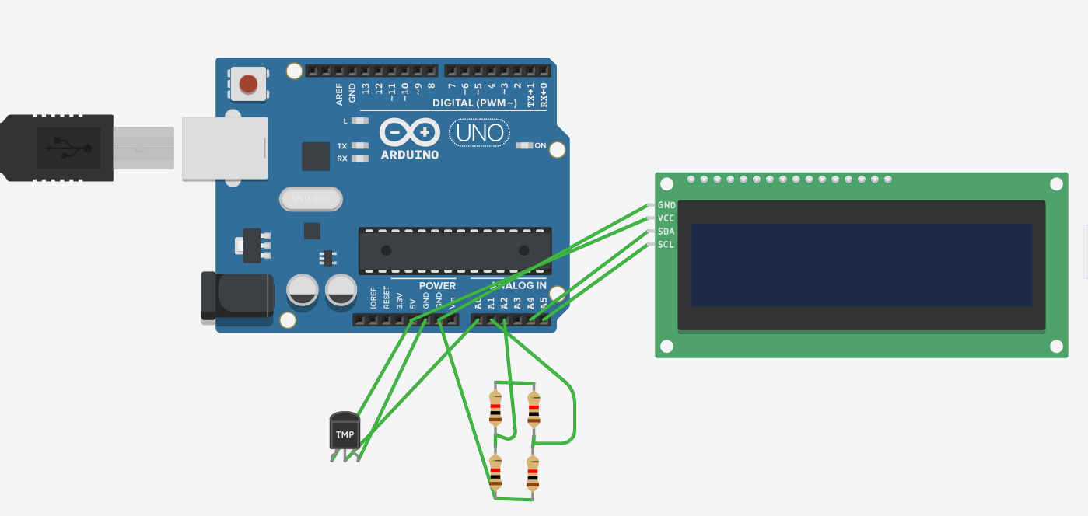
Circuit diagram

SPECIFICATION AND DETAILS
ARDUINO UNO
Technical Specifications

The Arduino Uno development board is based on the Atmel ATmega328, an 8-bit, 16 MHz microcontroller with 14 digital input/output (I/O) pins, 6 of which are capable of pulse-width modulation (PWM), as well as a 6-channel, 10-bit analog-to-digital converter. Digital communication capabilities include UART TTL serial, SPI serial, and two-wire interface serial (I2C). The Arduino development platform features a cross-platform, Java-based IDE as well as a C/C++ library which offers high-level access to hardware functions.

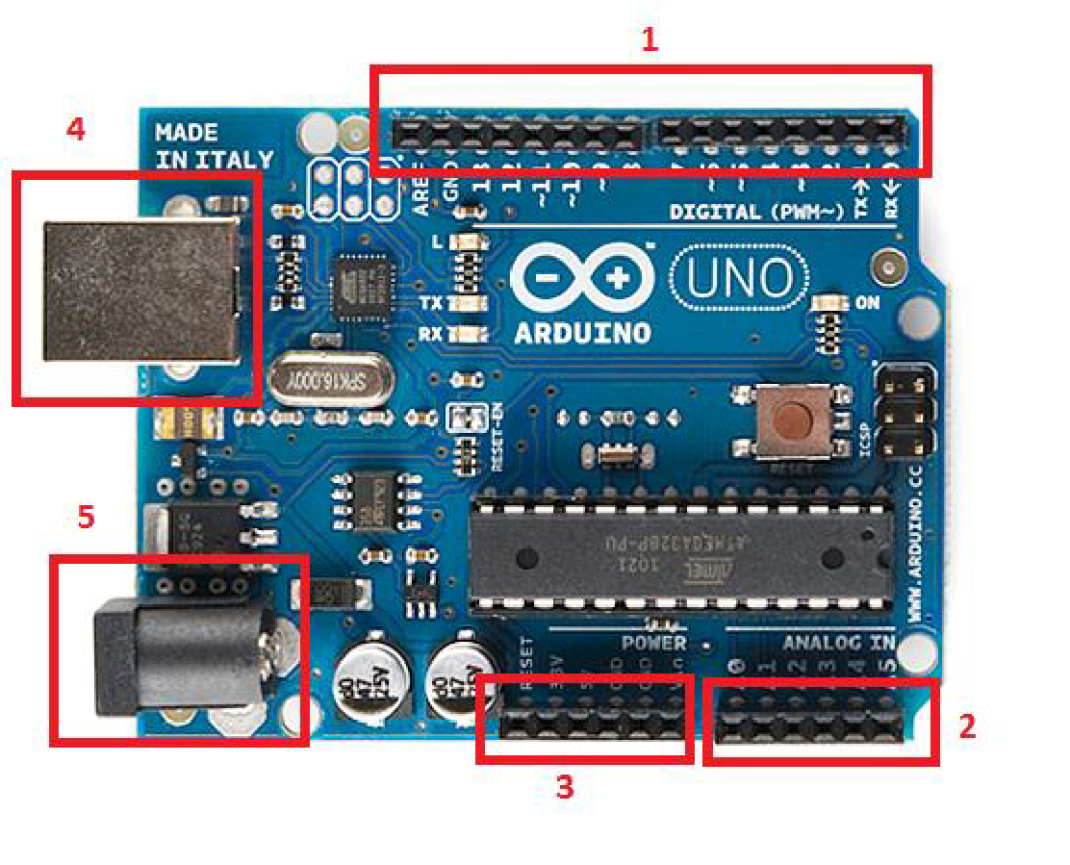

The Major Features of Microcontroller ATmega328P:
High Performance, Low Power Atmel®AVR® 8-Bit Microcontroller Family
• Advanced RISC Architecture
– 131 Powerful Instructions
– Most Single Clock Cycle Execution
– 32 x 8 General Purpose Working Registers
– Fully Static Operation
– Up to 20 MIPS Throughput at 20MHz
– On-chip 2-cycle Multiplier
• High Endurance Non-volatile Memory Segments
– 32KBytes of In-System Self-Programmable Flash program
Memory
– 1KBytes EEPROM
– 2KBytes Internal SRAM
– Write/Erase Cycles: 10,000 Flash/100,000 EEPROM

LIQUID CRYSTAL DISPLAY (LCD):
- LCD is used in a project to visualize the output of the application.
- We have used 16x2 LCD which indicates 16 columns and 2 rows. So, we can write 16 characters in each line. So, total 32 characters we can display on 16x2 LCD.
- LCD can also use in a project to check the output of different modules interfaced with the microcontroller. Thus, LCD plays a vital role in a project to see the output and to debug the system module wise in case of system failure in order to rectify the problem.

3.2.1 LCD Power Sources:

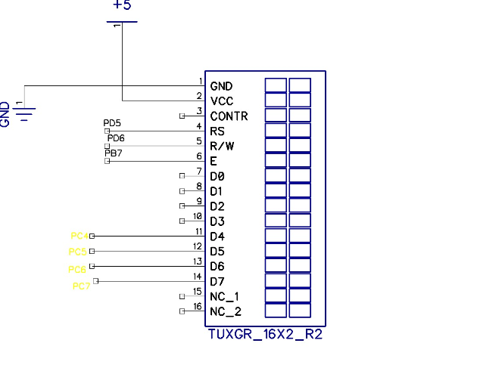
Figure 6: Pin Diagram of LCD

- LCD has 2 Power Sources
- 1. VCC and GND are at 1 and 2 NO. Pins of LCD. Used to drive the LCD 3mA current consumption.
- 2. VCC and GND are at 15 and 16 NO. pins of LCD used to drive the backlight of LCD 100 mA current
- Total current consumption = 3mA + 100mA = 103 mA
- So, in order to reduce the current requirement, we are connecting a 330-ohm resistance in series with the backlight pin VCC. This reduces the current consumption (100mA / 330 ohm =0.303 mA).
Therefore, new total current consumption = 0.303Ma

Pin No. | Symbol | Function
1 | GND | GROUND
2 | VCC | + 5 V
3 | CONTRAST | GND
4 | E | ENABLE
5 | RS | REGISTER SELECT
6 | R/W | READ WRITE
7 | DB0 | DATA LINE
8 | DB1 | DATA LINE
9 | DB2 | DATA LINE
10 | DB3 | DATA LINE
11 | DB4 | DATA LINE
12 | DB5 | DATA LINE
13 | DB6 | DATA LINE
14 | DB7 | DATA LINE
15 | VCC | + 5 V
16 | GND | GND

Table 1: LCD Pin description

9.4. Power supply

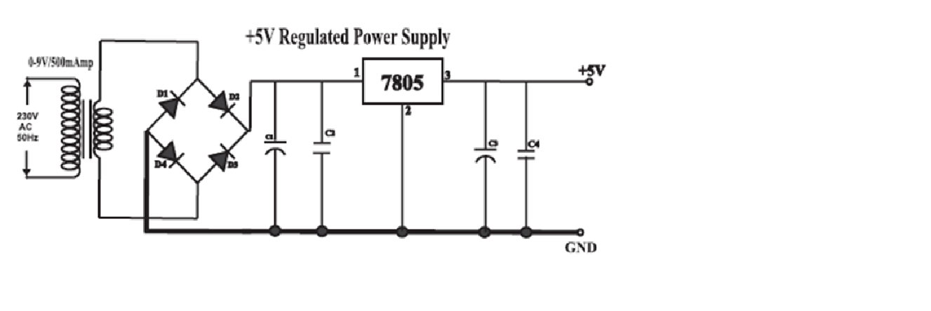
Figure 7: Circuit Diagram-Power Supply
- The basic step in the designing of any system is to design the power supply required for that system. The steps involved in the designing of the power supply are as follows,
1) Detership the total current that the system sinks from the supply.
2) Detership the voltage rating required for the different components.
- The bridge rectifier and capacitor i/p filter produce an unregulated DC voltage which is applied at the I/P of 7805.
- The minimum dropout voltage is 2v for IC 7805, the voltage applied at the input terminal should be at least 7 volts.
- C1 (1000 µf / 65v) is the filter capacitor.
- C2, C4 (0.1uF ceramic), C3 (220uF/25V electrolytic capacitor) are to be connected across the regulator to improve the transient response of the regulator.
- Assuming the drop out voltage to be 2 volts, the minimum DC voltage across the capacitor C1 should be equal to 7 volts (at least).

3.2.2 Power supply component design
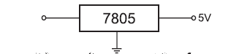

3.2.2.1. Transformer Design
We require +5V o/p. The drop-out voltage of regulator is 2V (As per datasheet).
Vdc = 5+2 = 7V
So, at the regulator input minimum 7V should be applied.
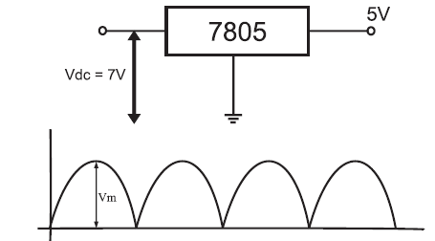
According to formula,
Vdc= 2Vm / pi.
Assuming there is no Ripple Capacitor
Hence From
Vm = Vdc. pi / 2.
= 7 x 3.14 / 2
= 10.99V
Vm = 10.99V
During one cycle, two diode are conducting, hence.
Drop of voltage of one diode = 0.7V
Drop of voltage of two diode = 1.4V

Vim = Vm + 1.4V
Vim = 10.99 + 1.4
Vim= 12.39V
Vrms = Vim / Sqrt (2)
=12.39 / Sqrt (2)
Vrms = 8.76V
Vim = 12.39V
Vrms = 8.76V
So we select transformer of 9V
Similarly, Im = Idc x pi / 2.
Im = 400m x 3.14 / 2
Im = 628mA
Irms = Im / Sqrt (2)
= 628m / Sqrt (2)
= 444.06 mA
Irms = 444.06mA
So, we select a transformer with a current rating of 500mA.
Considering voltage and current transformer
we take Transformer - 0-9V / 500mA Step down transformer.

9.4.1.2. Rectifier Design
PIV of diode = Vm = 12.39 V
Im = 628 mAmp
So, we selected a bridge IC of 1 Ampere rating.
9.4.1.3. Filter capacitor Design
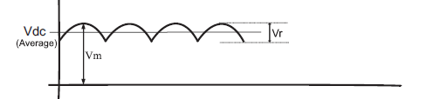
R = Vdc / Idc
= 7 / 400m
= 17.5 Ohms
Vr = 2 (Vim - Vdc)
= 2(12.39 - 7)
Vr = 10.78V
C = Vdc / (F x R x Vr)
= 7 / (100x17.5x10.78)
C =371.05uF
So, for safe working we select capacitor 0f 1000uF
C = 1000uF / 35V
C1 - 1000uF/35V - Electrolytic Capacitor
C2, C4 -0.1uF Ceramic Capacitor
C3 -220uF/25V Electrolytic Capacitor

Why 11.0592 MHz?
Serial data communication needs often dictate the frequency of the oscillator because of the requirement that internal counters must divide the basic clock rate to yield standard communication baud rates. If the basic clock frequency is not divisible without a reminder, then the resulting communication is not standard.

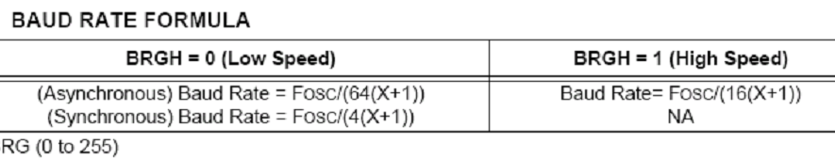

Table 2: BAUD RATE FORMULA

Here we keep.
SPBRG = 143; for 4800 baud rate and 71 for 9600 baud rates
BRGH = 1; high speed
Therefore 11.0592 MHz / 16 (143 +1).
11.0592 MHz / 16(144).
11.592 / 2304.
4800s/sec (a standard communication baud rate)

3.3 Battery Pack
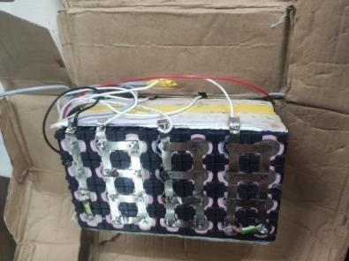

Figure 3.3: Battery Pack

We made a Battery pack from a lithium-ion battery pack of 24 Volt and 10.6 Amp. We took each cell of 3.7 Volt and 2600 mA. We took 7 Lithium Ion cells in series and we clamped it together. We made 4 sets like this and then we clamped it together to get desired voltage and current.

3.4 Arduino IDE

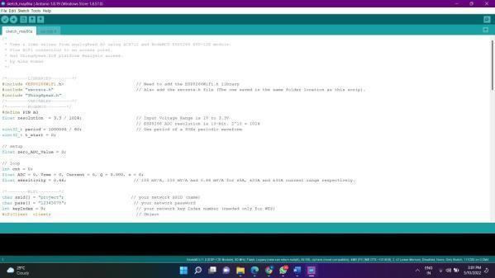
Figure 3.8: Arduino IDE

The Arduino IDE (Integrated Development Environment) is a piece of official Arduino.cc software that allows you to code and write accordingly on an Arduino environment. This open-source programme is very simple to install, understand learning syntax and is suitable with almost all Arduino modules.

Code:

#include <Wire.h>
int offset =20.
#include <LiquidCrystal_I2C.h>
LiquidCrystal_I2C lcd (0x27, 16, 2);
float h.
float t.
#include "DHT.h" // including the library of DHT11 temperature and humidity sensor
#define DHTTYPE DHT11 // DHT 11

#define dht_dpin 4
DHT dht (dht_dpin, DHTTYPE);
#include <SoftwareSerial.h>
//#include <dht11.h>
#define RX 2
#define TX 3

String AP = "byp”; // AP NAME
String PASS = "Byp12345678"; // AP PASSWORD
String API = "THNFXYWDMTGUG3SW”; // Write API KEY
String HOST = "api.thingspeak.com”.
String PORT = "80”.
int countTrueCommand.
int countTimeCommand.
boolean found = false.
int valSensor = 1.

SoftwareSerial esp8266(RX, TX);

void setup ()
{
Serial.begin(9600).
pinMode(A0, INPUT);
pinMode(10, OUTPUT);
pinMode(11, OUTPUT);
pinMode(12, OUTPUT);
pinMode(8, OUTPUT);
digitalWrite (11,1);
digitalWrite (12,1);
digitalWrite (10,1);
digitalWrite (8,0);
lcd. init();
dht. begin();
lcd. backlight();
lcd. setCursor(1,0); //(IOT) Based Weather Monitoring system
lcd.print ("IOT BASED BMS ");
delay (2000);
lcd. clear();

esp8266.begin(115200).
sendCommand("AT",5,"OK").
sendCommand("AT+CWMODE=1",5,"OK").
sendCommand ("AT+CWJAP=\""+ AP +"\",\""+ PASS +"\"",20,"OK");

}

void loop ()
{

lcd.print("TEMPERATURE:").
lcd. setCursor(13,0);
lcd.print(getTemperatureValue ());
lcd. setCursor(0,1);
lcd.print("HUMIDITY:").
lcd. setCursor(13,1);
lcd.print(getHumidityValue ());
delay (2000);
lcd. clear();

lcd.print("VOLTAGE:").
lcd. setCursor(8,0);
lcd.print(bpm ());
delay (2000);
lcd. clear();
String getData = "GET /update?api_key="+ API +"&field1="+getTemperatureValue() +"&field2="+getHumidityValue()+"&field3="+bpm();
sendCommand("AT+CIPMUX=1",5,"OK").
sendCommand ("AT+CIPSTART=0,\"TCP\",\""+ HOST +"\","+ PORT,15,"OK");
sendCommand ("AT+CIPSEND=0," +String(getData.length()+4),4,">");
esp8266.println(getData); delay(500);countTrueCommand++;
sendCommand("AT+CIPCLOSE=0",5,"OK").

}

String getTemperatureValue (){
h = dht. readHumidity();
t = dht. readTemperature();

Serial.print("Current humidity = ").
Serial.print(h).
Serial.print("% “);
Serial.print("temperature = ").
Serial.print(t).
Serial.print("C “);

if(t>=45)
{

digitalWrite (10,0);
digitalWrite (8,1);
delay (3000);
digitalWrite (8,0);
delay (3000);

delay (2000);
lcd. clear();

lcd. setCursor(0,0);
lcd.print ("TEMP HIGH");

delay (2000);
lcd. clear();
}
if(t<=45)
{

digitalWrite (10,1);

Serial.print("Current humidity = ").
Serial.print(h).
Serial.print("% “);
Serial.print("temperature = ").
Serial.print(t).
Serial.print("C “);
}
if(t<=5)
{

digitalWrite (11,0);

}
if(t>=10)
{

digitalWrite (11,1);

}
return String(t).

}

String getHumidityValue (){
h = dht.readHumidity();
t = dht.readTemperature();

Serial.print("Current humidity = ");
Serial.print(h);
Serial.print("% ");
Serial.print("temperature = ");
Serial.print(t);
Serial.print("C ");

return String(h);

}

String bpm(){

int volt = analogRead(A0);
double voltage = map(volt,0,1023, 0, 2526) + offset;

voltage /=120;
Serial.print("voltage: ");
Serial.print(voltage);
Serial.println("v");

if(voltage<=5)
{

digitalWrite(12,0);
digitalWrite(8,1);
delay(3000);
digitalWrite(8,0);
delay(3000);
lcd.clear();

lcd.setCursor(3,0);
lcd.print("VOLTAGE LOW ");
delay(2000);
lcd.clear();

delay(3000);

digitalWrite(13,0);
delay(3000);
}
if(voltage>=10)
{

digitalWrite(12,1);

}

return String(voltage);

}

void sendCommand(String command, int maxTime, char readReplay[]) {
Serial.print(countTrueCommand);
Serial.print(". at command => ");
Serial.print(command);
Serial.print(" ");
while(countTimeCommand < (maxTime*1))
{
esp8266.println(command);//at+cipsend
if(esp8266.find(readReplay))//ok
{
found = true;
break;
}

countTimeCommand++;
}

if(found == true)
{
Serial.println("Conn");
countTrueCommand++;
countTimeCommand = 0;
}

if(found == false)
{
Serial.println("Fail");
countTrueCommand = 0;
countTimeCommand = 0;
}

found = false;
}

Chapter 3
Results and discussions

HARDWARE AND RESULTS

Hardware Implementation and Results for Battery Monitoring System Using IoT

4.1 Hardware Implementation:

The Battery Monitoring System (BMS) utilizing Internet of Things (IoT) technology involves the integration of several hardware components to enable real-time monitoring and analysis of battery parameters. The hardware setup typically includes:

1. IoT-enabled Sensors: These sensors are deployed to measure key parameters such as voltage, current, temperature, and state of charge of the batteries. Depending on the application, various types of sensors, such as voltage sensors, current sensors, temperature sensors, and humidity sensors, may be employed.
2. Microcontrollers or Single Board Computers: Microcontrollers or single board computers, such as Arduino, Raspberry Pi, or ESP32, are used to interface with the sensors, collect data, and transmit it to the cloud or a central monitoring system. These devices provide the computational power and connectivity required for IoT communication.
3. Communication Modules: Communication modules, such as Wi-Fi, Bluetooth, or cellular modules, are integrated with the microcontrollers to enable wireless data transmission to the cloud or a centralized server. These modules ensure seamless connectivity and enable remote monitoring and control of battery systems.
4. Power Supply: A stable and reliable power supply is essential to ensure uninterrupted operation of the monitoring system. This may involve battery backup systems or power conditioning devices to mitigate the risk of power outages or fluctuations.
5. Enclosures and Mounting Hardware: Enclosures and mounting hardware are used to protect the hardware components from environmental factors and secure them in place, especially in outdoor or harsh environments.

4.2 Component list

- Atmega 328 smd controller
- DHT11 module
- Voltage divider module
- 10k pot
- Li Battery
- Battery Cell Holder
- BMS
- LCD 16x2
- Buzzer
- Motor
- 1-channel Relay
- IOT

- Atmega 328 smd controller

The Atmega328 is a popular microcontroller commonly used in various embedded applications, including battery monitoring systems. Its small surface-mount device (SMD) package makes it suitable for compact designs and low-power applications, which align well with the requirements of battery monitoring systems.

In a battery monitoring system, the Atmega328 can be utilized to perform tasks such as:

1. Voltage Monitoring: It can read the voltage level of the battery cells or battery packs through analog inputs or digital interfaces such as I2C or SPI.
2. Current Monitoring: By interfacing with current sensing components like shunt resistors or Hall effect sensors, the Atmega328 can measure the current flowing in and out of the battery.
3. Temperature Monitoring: Monitoring battery temperature is crucial for safety and performance. The Atmega328 can interface with temperature sensors to measure the temperature of the battery cells or surrounding environment.
4. Data Processing: It can process the collected data, perform calculations, and make decisions based on predefined algorithms or user-defined logic.
5. Communication: The Atmega328 can communicate with external devices or systems for data logging, reporting, or control purposes. This can be achieved through UART, SPI, I2C, or other communication protocols.
6. Low-Power Operation: With its low-power features and sleep modes, the Atmega328 can efficiently manage power consumption, prolonging battery life in the monitoring system itself.
7. User Interface: It can interface with user input devices such as buttons or touch sensors and output devices like displays or LEDs to provide user feedback or control options.
8. Alarm Generation: Based on predefined thresholds or conditions, the Atmega328 can trigger alarms or notifications to alert users about critical battery conditions such as overvoltage, undervoltage, overcurrent, or overheating.

Overall, the Atmega328's versatility, low-power capabilities, and integration features make it well-suited for battery monitoring applications, where reliability, efficiency, and compactness are essential.

- DHT11 module

The DHT11 module is a low-cost sensor commonly used to measure temperature and humidity. While it's not typically used directly for battery monitoring, it can still play a role in the broader context of environmental monitoring within a battery system. Here's how it could be applied:

1. Environmental Monitoring: The DHT11 can be used to measure the ambient temperature and humidity around the battery system. High temperatures can accelerate battery degradation, while humidity can affect certain types of batteries as well.
2. Enclosure Control: In battery systems, especially those used outdoors or in harsh environments, maintaining the right environmental conditions within the enclosure is crucial. The DHT11 can help monitor these conditions, and the battery management system (BMS) can take action if conditions exceed safe thresholds. For instance, if the temperature rises too high, the BMS could activate ventilation or cooling systems to prevent overheating.
3. Data Logging: While not the primary function of a battery monitoring system, logging environmental data can provide valuable insights over time. The DHT11, along with other sensors, can contribute to this dataset, helping operators understand how environmental factors impact battery performance and lifespan.
4. Alerting and Safety: Extreme temperature or humidity conditions can be dangerous for both the batteries and the surrounding equipment. Integrating the DHT11 into the monitoring system allows for early detection of such conditions, triggering alarms or shutdown procedures to prevent damage or accidents.
5. Calibration: In some cases, battery performance can be influenced by environmental conditions. By monitoring temperature and humidity alongside battery parameters, the system can adjust its calculations or algorithms to account for these factors, improving the accuracy of battery state estimation and management.

While the DHT11 may not directly measure parameters like voltage or current crucial for battery monitoring, its role in environmental monitoring is complementary and can enhance the overall safety and performance of the battery system.

- Voltage divider module

A voltage divider module is a simple electronic circuit commonly used to reduce voltage levels for measurement or control purposes. In a battery monitoring system, voltage divider modules can serve several important functions:

1. Voltage Measurement: One of the primary tasks of a battery monitoring system is to measure the voltage of the battery cells or packs. Since microcontrollers like the Atmega328 often have limited input voltage ranges, a voltage divider is used to scale down the battery voltage to a level that the microcontroller can safely measure. By carefully selecting resistor values in the voltage divider circuit, the battery voltage can be scaled down while maintaining measurement accuracy.
2. Overvoltage Protection: In addition to measuring battery voltage, voltage divider modules can also be used for overvoltage protection. By monitoring the scaled-down voltage, the monitoring system can detect when the battery voltage exceeds a safe threshold. This information can be used to trigger alarms or safety measures to prevent damage to the battery or connected devices.
3. Under Voltage Detection: Similarly, voltage dividers can be used to detect when the battery voltage falls below a certain threshold, indicating that the battery is discharged or nearing depletion. This information can be used to trigger low battery warnings or shutdown procedures to prevent damage to connected equipment or ensure timely recharging.
4. Voltage Regulation Feedback: In systems where voltage regulation is required, such as in solar or battery charging applications, voltage dividers can provide feedback to control circuits to adjust charging or discharging currents accordingly. By continuously monitoring the battery voltage, the charging system can optimize performance and ensure safe operation.
5. Calibration and Accuracy: Voltage dividers may require calibration to ensure accurate voltage measurements. By comparing the scaled-down voltage with a reference voltage, the monitoring system can calibrate the voltage divider circuit to compensate for any inaccuracies introduced by component tolerances or environmental factors.

Overall, voltage divider modules are essential components in battery monitoring systems, enabling accurate voltage measurements, overvoltage and undervoltage protection, and feedback control for charging and discharging processes. Their simplicity, reliability, and versatility make them well-suited for a wide range of battery monitoring applications.

- 10k potentiometer

A 10k potentiometer, short for potentiometer, is a type of variable resistor with a resistance of 10,000 ohms (10kΩ). It consists of a resistive element and a wiper that can be adjusted to vary the resistance between its terminals. In a battery monitoring system, a 10k potentiometer can be used for various purposes:

1. Voltage Reference: The potentiometer can be used to provide a variable voltage reference for calibration purposes. By adjusting the wiper position, the system can simulate different battery voltage levels to verify the accuracy of voltage measurement circuits.
2. Threshold Adjustment: Potentiometers can be used to set voltage thresholds for overvoltage or undervoltage protection circuits. By adjusting the potentiometer, the user can configure the system to trigger alarms or safety measures when the battery voltage exceeds or falls below specific thresholds.
3. Analog Input Adjustment: In systems with analog input requirements, such as microcontroller-based battery monitoring systems, potentiometers can be used to vary input voltages within a predefined range. This allows for testing and calibration of analog input circuits to ensure accurate measurement and monitoring of battery parameters.
4. User Interface Control: Potentiometers can serve as user interface elements for manual adjustment of system parameters. For example, in a battery charger, a potentiometer can be used to adjust the charging current or voltage level based on user preferences or battery specifications.
5. Feedback Control: Potentiometers can provide feedback signals for closed-loop control systems in battery charging or discharging circuits. By adjusting the potentiometer, the system can regulate charging or discharging currents to maintain desired battery performance characteristics.

Overall, the 10k potentiometer is a versatile component that can be used in various aspects of battery monitoring systems, including calibration, threshold adjustment, user interface control, and feedback control. Its simplicity and ease of use make it a valuable tool for customizing and fine-tuning system parameters to meet specific application requirements.

- Li Battery

Lithium-ion (Li-ion) batteries are widely used in battery monitoring systems due to their high energy density, lightweight, and rechargeable nature. Here's how Li-ion batteries are used and their applications in battery monitoring systems:

1. Energy Storage: Li-ion batteries serve as the primary energy storage source in many battery monitoring systems. These systems can range from small portable devices to large-scale energy storage systems used in renewable energy applications. Li-ion batteries provide a reliable and efficient means of storing electrical energy for later use.
2. Uninterruptible Power Supplies (UPS): Battery monitoring systems employing Li-ion batteries are often integrated into UPS systems to provide backup power during mains power failures. In such systems, battery monitoring is crucial to ensure that the batteries are adequately charged and maintained to provide backup power when needed. Monitoring parameters such as voltage, current, temperature, and state of charge (SoC) ensure the UPS remains ready to provide uninterrupted power supply.
3. Electric Vehicles (EVs): Li-ion batteries are the primary energy storage technology in electric vehicles. Battery monitoring is essential in EVs to ensure optimal performance, safety, and longevity of the battery pack. Monitoring parameters such as cell voltage, temperature, and state of charge (SoC) help manage charging and discharging processes, prevent overcharging or over-discharging, and ensure even cell balancing for extended battery life.
4. Renewable Energy Storage: Li-ion batteries are used in conjunction with renewable energy sources such as solar and wind power to store excess energy for later use. Battery monitoring systems help manage the charging and discharging of the batteries based on energy demand and supply fluctuations. This ensures efficient utilization of renewable energy and grid stability.
5. Telecommunications: Li-ion batteries are commonly used as backup power sources in telecommunications infrastructure, such as cell towers and data centers. Battery monitoring systems in these applications ensure that backup batteries are maintained at optimal conditions to provide reliable backup power during power outages or grid failures.
6. Industrial and Commercial Applications: Li-ion batteries find applications in various industrial and commercial settings, such as uninterruptible power supplies for critical equipment, emergency lighting systems, and portable power tools. Battery monitoring systems help ensure the reliability and safety of these applications by continuously monitoring battery parameters and providing early warnings of potential issues.

In all these applications, battery monitoring systems play a critical role in ensuring the safe and efficient operation of Li-ion batteries. By monitoring key parameters and providing real-time data, these systems help optimize battery performance, prolong battery life, and prevent potential safety hazards.

- Battery Cell Holder
Battery cell holders are mechanical devices designed to securely hold individual battery cells in place within an electronic device or circuit. These holders facilitate easy insertion and removal of batteries, making them convenient for both testing and replacement purposes. In battery monitoring systems, battery cell holders serve several important functions:

1. Battery Interfacing: Battery cell holders provide a physical interface between the battery cells and the monitoring system. They ensure proper electrical contact between the battery terminals and the monitoring circuitry, allowing for accurate measurement of battery parameters such as voltage, current, and temperature.
2. Modularity and Flexibility: Battery cell holders offer modularity and flexibility in battery monitoring systems. They allow for easy replacement or upgrading of individual battery cells without the need for soldering or other complex procedures. This modular approach simplifies maintenance and repair tasks, reduces downtime, and enables scalability in battery systems.
3. Compatibility: Battery cell holders come in various shapes and sizes to accommodate different types of battery cells, such as cylindrical, coin cell, or prismatic cells. This compatibility ensures that the monitoring system can support a wide range of battery chemistries and form factors, including lithium-ion, nickel-metal hydride, alkaline, and others.
4. Mechanical Protection: Battery cell holders provide mechanical protection for the battery cells, preventing accidental short circuits or damage during handling or operation. They also help maintain the alignment and orientation of the battery cells within the system, ensuring reliable and consistent performance.
5. Easy Access for Testing and Maintenance: Battery cell holders allow for easy access to individual battery cells for testing, maintenance, or replacement purposes. This accessibility simplifies troubleshooting tasks and enables quick identification and resolution of battery-related issues, such as low voltage, high temperature, or cell imbalance.
6. Integration with Battery Management Systems (BMS): Battery cell holders can be integrated with advanced battery management systems to enhance monitoring and control capabilities. For example, some cell holders feature built-in sensors or communication interfaces that enable real-time monitoring of battery parameters and remote management of battery systems.

Overall, battery cell holders play a crucial role in battery monitoring systems by providing a reliable and versatile interface between the battery cells and the monitoring circuitry. Their modularity, compatibility, and ease of use make them essential components for building robust and scalable battery monitoring solutions.

4.3 Results:

Upon successful implementation of the hardware components, the Battery Monitoring System using IoT yields several key results and benefits:

1. Real-Time Monitoring: The system provides real-time monitoring of battery parameters, enabling stakeholders to access up-to-date information on battery performance and health status remotely.
2. Data Visualization: The collected data is visualized through user-friendly dashboards or interfaces, allowing users to easily interpret and analyze the information. Graphs, charts, and alerts provide insights into trends, anomalies, and potential issues.
3. Predictive Maintenance: By analyzing historical data and applying predictive analytics algorithms, the system can identify patterns and trends indicative of potential battery degradation or failure. Early detection of issues enables proactive maintenance and minimizes downtime.
4. Remote Control and Management: The IoT-enabled BMS allows for remote control and management of battery systems, including adjusting charging parameters, implementing energy optimization strategies, and receiving alerts or notifications in case of abnormalities.
5. Optimization of Energy Utilization: Through continuous monitoring and analysis, the system facilitates optimization of energy utilization, ensuring efficient use of battery resources and maximizing system performance and lifespan.

Overall, the hardware implementation of the Battery Monitoring System using IoT provides actionable insights, enhances operational efficiency, and contributes to the sustainability and reliability of battery-powered applications. By leveraging IoT technology, organizations can effectively manage and optimize their battery assets, driving towards a more resilient and sustainable energy future.

We took a conventional bicycle. After this we took a BLDC chain motor of 250 W. We fixed that BLDC motor into our bicycle to make it an electric bicycle. We make a battery pack of 24 V and 10.4 A. We took the Lb27 Controller box for controlling the motor. After mounting it to our bicycle we had to make a battery health care where we can see the various aspects of the battery. For monitoring different aspects, we took a current sensor (ACS 712), voltage sensor, Temperature sensor(DH11) and NodeMCU (ESP8266). We made 3 different modules for measuring each component. In the current module we used an ACS712 current sensor that can measure maximum 30 Am. We connected it to the Arduino IOT cloud to monitor it live. Now we made a separate module for measuring voltage and we can determine voltage less than 25 V. In the same way we are sending data to Arduino IOT cloud to determine voltage .We are also monitoring Battery percentage. For the last part we are using temperature sensor DH11 to monitor battery Temperature. We can monitor battery voltage up to 50 degrees Celsius and we are also monitoring humidity. We are connecting it to the Arduino IOT cloud to monitor the same.

Chapter 4
Conclusions and future scope

CONCLUSION

In conclusion, the implementation of a Battery Monitoring System (BMS) utilizing Internet of Things (IoT) technology represents a significant advancement in the realm of energy management and sustainability. Through this integration, we have achieved a sophisticated framework capable of real-time monitoring, analysis, and optimization of battery performance across diverse applications.
The deployment of IoT-enabled sensors facilitates seamless data acquisition from battery systems, providing granular insights into key parameters such as voltage, current, temperature, and state of charge. This wealth of data empowers stakeholders with actionable intelligence to make informed decisions regarding battery health, utilization, and maintenance strategies.
Moreover, the IoT-based architecture enables remote monitoring and control of battery assets, offering unparalleled flexibility and scalability in managing distributed energy resources. Whether deployed in electric vehicles, renewable energy systems, or grid-scale storage facilities, this technology facilitates proactive maintenance, predictive analytics, and efficient resource allocation.
Furthermore, the integration of machine learning algorithms and predictive analytics enhances the predictive capabilities of the system, enabling early detection of potential faults or degradation trends. By leveraging historical data and pattern recognition techniques, the BMS can anticipate and mitigate issues before they escalate, thus minimizing downtime and optimizing battery lifespan.
In addition to operational benefits, the IoT-enabled BMS contributes to broader sustainability goals by optimizing energy utilization, reducing waste, and enhancing overall system efficiency. By maximizing the performance and lifespan of battery assets, organizations can minimize environmental impact and achieve greater economic value from their investments in energy storage technology.
Looking ahead, the continued evolution of IoT technology promises even greater advancements in battery monitoring and management. As sensor technologies become more affordable and ubiquitous, and connectivity solutions become more robust and standardized, the potential for innovation in this space is boundless.
In conclusion, the convergence of IoT and battery monitoring systems heralds a new era of intelligent energy management, driving progress towards a more sustainable and resilient energy future. Through ongoing research, collaboration, and innovation, we can unlock the full potential of this transformative technology to address the challenges of tomorrow and build a cleaner, more efficient energy ecosystem for generations to come. The proposed system is useful in monitoring and tracking the properties of the battery in real time. The battery plays a vital role in an Electric vehicle. Therefore, monitoring of the Battery is very important. The project proposed a new way of monitoring the battery with the help of IOT. The sensors incorporated in the proposed system can collect the data of the battery such as voltage, temperature and current, these data are then sent to Arduino IOT Cloud. Thus, the real time data collection, storage and monitoring of the battery of an electric vehicle is possible with the system. By tracking these variables, it will be easier to determine the battery’s health or longevity, and pricing will be adjusted accordingly, as a less efficient battery with a shorter life cycle will cost more than a more efficient battery with a longer life cycle. This helps in identifying and solving a problem before a failure without human dependency. In addition, measured data helps to develop a battery swapping station and its price fixing.

Future Scope
The future scope in Battery Management Systems (BMS) is extremely promising, driven by the rapid advancement of battery technology and the growing demand for energy storage solutions. Here are several key areas where expertise in BMS can lead to significant opportunities: 1. Electric Vehicles (EVs) Design and Development: Working on advanced BMS for EVs to improve battery efficiency, safety, and longevity. Manufacturing: Involvement in the production of BMS for major automotive companies. Testing and Validation: Ensuring that BMS meet regulatory standards and performance criteria. 2. Renewable Energy Integration Energy Storage Systems: Developing BMS for large-scale battery storage systems used in conjunction with renewable energy sources like solar and wind. Microgrids: Implementing BMS in microgrid solutions to manage and optimize distributed energy resources. 3. Consumer Electronics Mobile Devices: Enhancing BMS for smartphones, laptops, and tablets to ensure better performance and longer battery life. Wearables: Developing efficient BMS for wearable technology, such as smartwatches and fitness trackers. 4. Grid Energy Storage Utility Companies: Working with utility companies to integrate battery storage solutions that stabilize the grid and provide backup power. Smart Grids: Implementing BMS in smart grids to optimize energy distribution and reduce outages. 5. Research and Development Innovation: Engaging in R&D to develop next-generation BMS technologies that enhance battery performance and safety. Collaboration: Partnering with academic and industrial research labs to push the boundaries of battery technology. 6. Aerospace and Defense Drones and UAVs: Developing BMS for drones and unmanned aerial vehicles, focusing on maximizing flight time and safety. Military Applications: Creating robust and reliable BMS for military equipment and vehicles. 7. Healthcare Medical Devices: Ensuring the reliability and safety of batteries in critical medical devices like pacemakers and portable diagnostic equipment. 8. **Industry Trends and Emerging Technologies Artificial Intelligence and Machine Learning: Implementing AI and ML algorithms in BMS to predict battery life, optimize charging cycles, and enhance overall system efficiency. Internet of Things (IoT): Integrating BMS with IoT to enable remote monitoring and management of battery systems. Advanced Materials: Researching and developing new battery materials (like solid-state batteries) that require sophisticated BMS to handle unique characteristics and improve performance. 9. Policy and Regulation Compliance: Ensuring that BMS designs meet evolving regulatory standards for safety and environmental impact. Sustainability: Developing systems that support the recycling and repurposing of batteries to meet sustainability goals. 10. Career Pathways BMS Engineer: Specializing in the design, development, and testing of BMS for various applications. Product Manager: Overseeing the development and market introduction of BMS products. Field Service Engineer: Providing technical support and maintenance for BMS in real-world applications. Research Scientist: Conducting cutting-edge research to advance BMS technology.

References
    - Rajashekara, K., 2013. Present status and future trends in electric vehicle propulsion technologies. IEEE journal of emerging and selected topics in power electronics, 1(1), pp.3-10.
    - Denton, T., 2020. Electric and hybrid vehicles. Routledge.

    - Zhang, F., 2017. Modelling and control of a modular battery management system for lithium-ion battery packs (Doctoral dissertation, University of Colorado at Boulder).
    - Hemmati, M., Aba pours, M. and Mohammadi-Ivalo, B., 2020. Optimal scheduling of smart Microgrid in presence of battery swapping station of electrical vehicles. In Electric Vehicles in Energy Systems (pp. 249-267). Springer, Cham.
    - Shah, F.A., Sheikh, S.S., Mir, U.I. and Athar, S.O., 2019, August. Battery health monitoring for commercialized electric vehicle batteries: Lithium-ion. In 2019 International Conference on Power Generation Systems and Renewable Energy Technologies (PGSRET) (pp. 1-6). IEEE.
[7] S. Jain, Z. Ahmad, M. S. Alam and Y. Rafat, "Battery Swapping Technology," 2020 5th IEEE International Conference on Recent Advances and Innovations in Engineering (ICRAIE),2020, pp.1-4,doi: 10.1109/ICRAIE51050.2020.9358366.
    - Maitreya, S., Jain, H. and Paliwal, P., 2021, February. Scalable and De- centralized Battery Management System for Parallel Operation of Multiple Battery Packs. In 2021 Innovations in Energy Management and Renewable Resources (52042) (pp. 1-7). IEEE.
[8] Ananthraj, C.R. and Ghosh, A., 2021, January. Battery Management System in Electric Vehicle. In 2021 4th Biennial International Conference on Nascent Technologies in Engineering (ICNTE) (pp. 1-6). IEEE.
[9] Kur’s, Andre; Moffatt, Robert; Solace, Marin, "Simultaneous midrange power transfer to multiple devices," Applied Physics Letters, vol.96, no.4, pp.044102, 044102-3, Jan
[10] Babu, V.V.P., Reddy, K.S., Jadhav, L.V., Bhavana, I., Sridhar, G. and Reddy, M.S., 2021, February. Design, modelling and fabrication of 4-wheeler electric short commuter. In AIP Conference Proceedings (Vol. 2317, No. 1, p. 050014). AIP Publishing LLC.

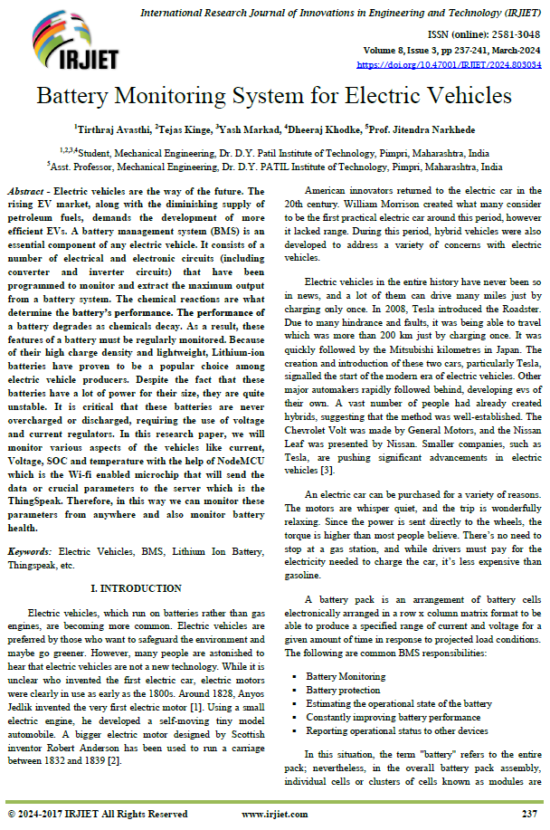
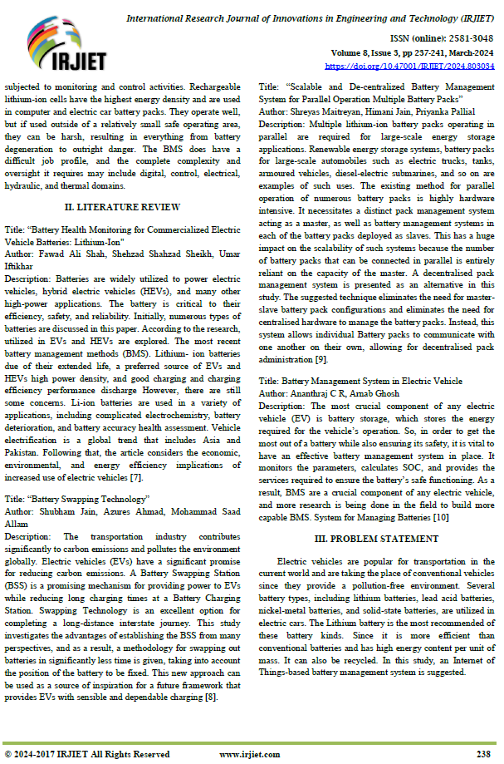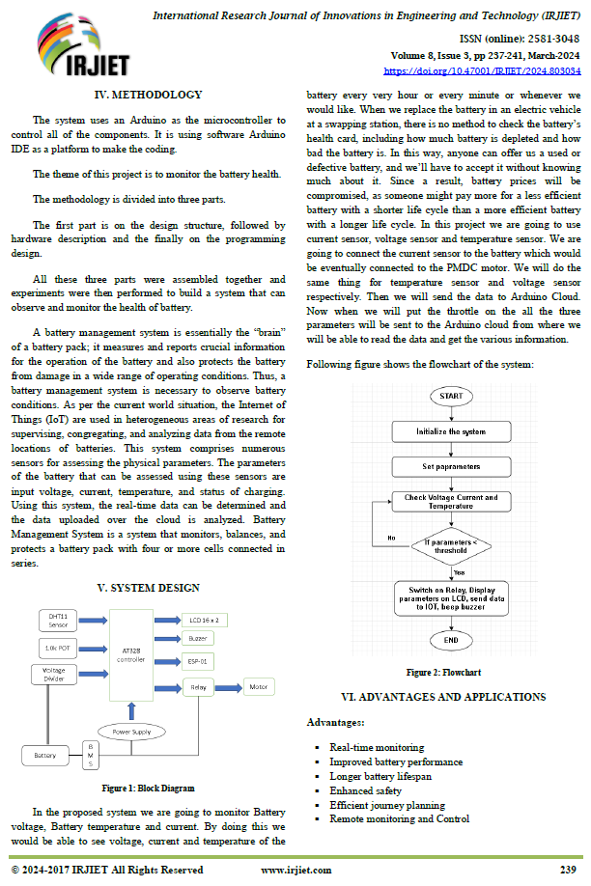
Appendix A:
Sample readings for the experiments conducted.

Appendix B:
Publication details
The results presented in this report have been submitted to a conference/journal, details of which are as mentioned under.

Name of the journal/conference:
Name of the authors with affiliation:
Contribution of authors:

Appendix C:
About the authors

Photo | Write here about the project group members.
Photo | Mobile No.:
Photo | Email:
Photo | Write here about the project group members.
Photo | Mobile No.:
Photo | Email:
 | Write here about the project group members.
 | Mobile No.:
 | Email:
 | Write here about the project group members.
 | Mobile No.:
 | Email:

